# 5 Free Courses on Reinforcement Learning

Learn about a subfield of machine learning, where the agent (model) learns to make decisions by interacting with the environment.

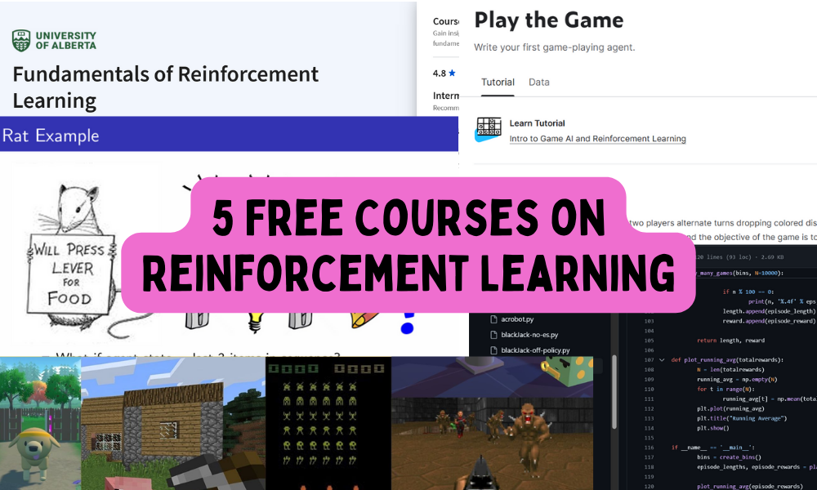

Image by Author

Reinforcement learning (RL) is a subfield of machine learning where an agent learns to make decisions by interacting with its environment rather than relying solely on pre-existing data. It is an area that blends trial-and-error learning with feedback from actions to improve future performance.

In this blog, we will explore 5 free courses that I believe are the best for beginners and professionals interested in entering the exciting field of self-learning robots.

## 1. Deep RL Course - Hugging Face

I highly recommend beginners to take and complete the [Deep RL Course](https://huggingface.co/learn/deep-rl-course/unit0/introduction) by Hugging Face within a month to understand the basics of reinforcement learning algorithms and advanced techniques for training agents in complex environments. I have completed this course myself, and trust me, I enjoyed experimenting with the models, trying different strategies to improve my scores, and climbing up the leaderboard.

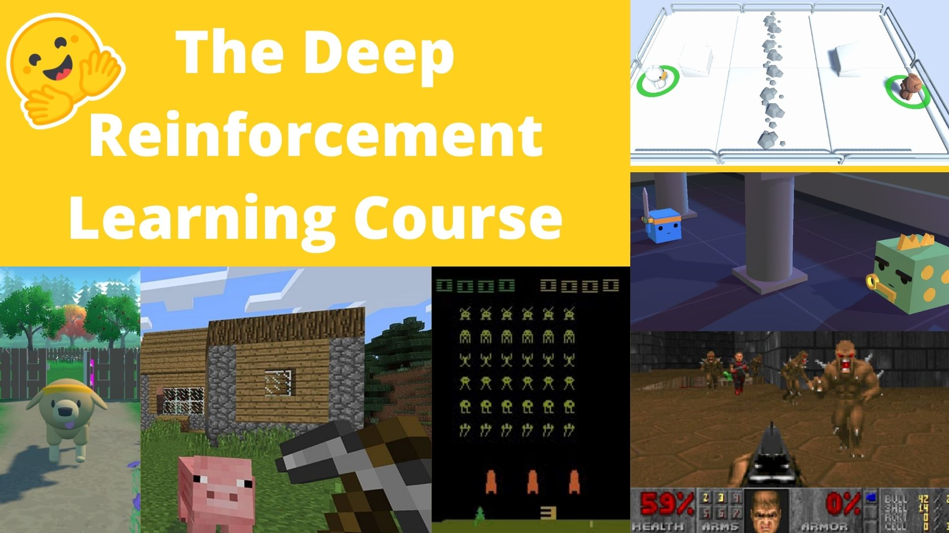

Throughout the course, you will learn the fundamentals of reinforcement learning, including Q-learning, deep Q-learning, policy gradients, ML agents, actor-critic methods, multi-agent systems, and advanced topics like RLHF (Reinforcement Learning from Human Feedback), Decision Transformers, and MineRL.

## 2. Learn Intro to Game AI and Reinforcement Learning - Kaggle

[Learn Intro to Game AI and Reinforcement Learning](https://www.kaggle.com/learn/intro-to-game-ai-and-reinforcement-learning) by Kaggle is an interactive mini course perfect for those who are interested in applying RL to game development. It covers the basics of game AI and introduces reinforcement learning concepts through interactive lessons and coding exercises.

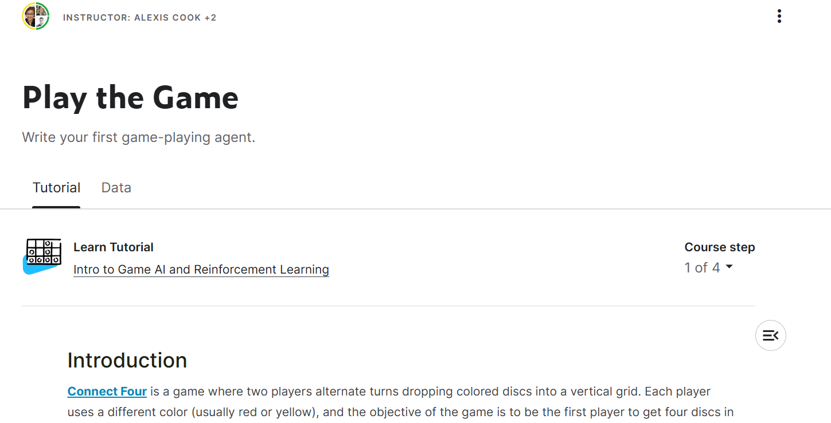

In the end, you will apply what you learn by working on the project called Halite.

## 3. Fundamentals of Reinforcement Learning - Coursera

[Fundamentals of Reinforcement Learning](https://www.coursera.org/learn/fundamentals-of-reinforcement-learning) by University of Alberta is part of the reinforcement learning specialization career track and is taught by experts in the field.

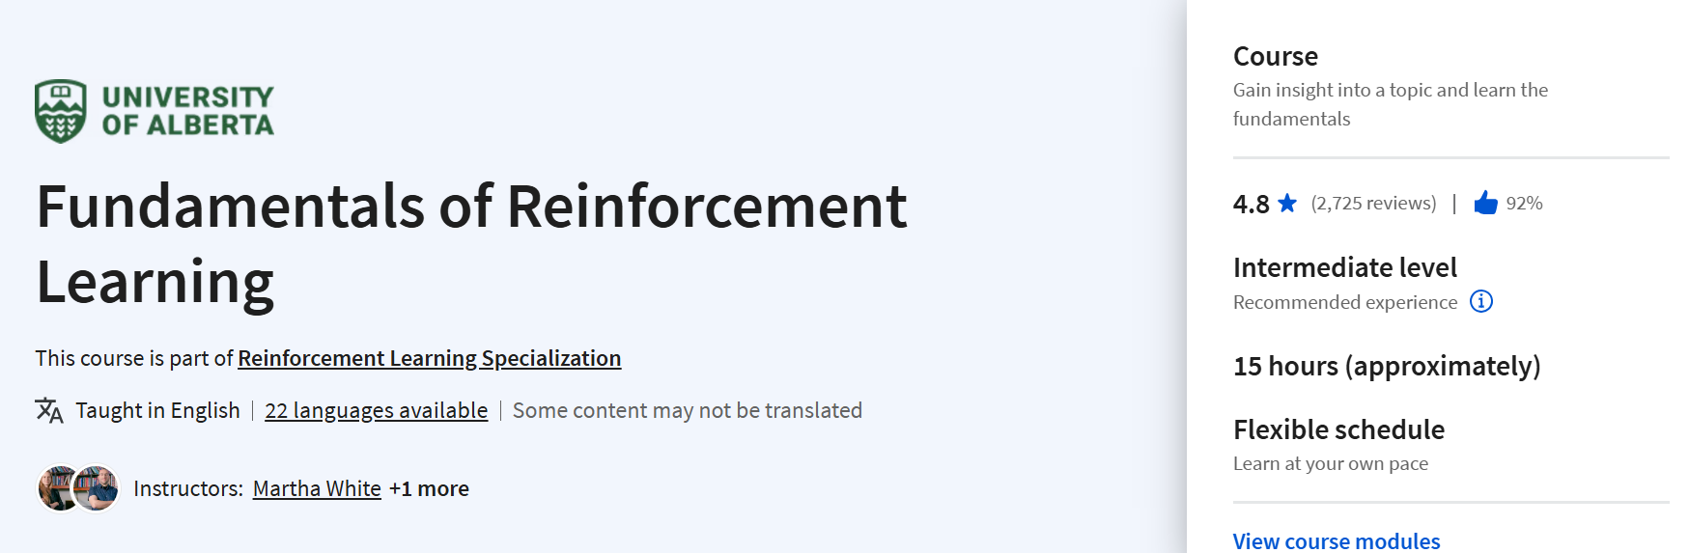

It covers the foundational principles of RL, including Markov decision processes, dynamic programming, and Monte Carlo methods. The course also includes practical assignments to reinforce the theoretical concepts learned.

## 4. Introduction to Reinforcement Learning - DeepMind x UCL

The [Introduction to Reinforcement Learning](https://www.youtube.com/playlist?list=PLqYmG7hTraZDM-OYHWgPebj2MfCFzFObQ) by DeepMind X UCL is a comprehensive YouTube series that delves into a wide range of topics, from foundational principles to advanced techniques in reinforcement learning.

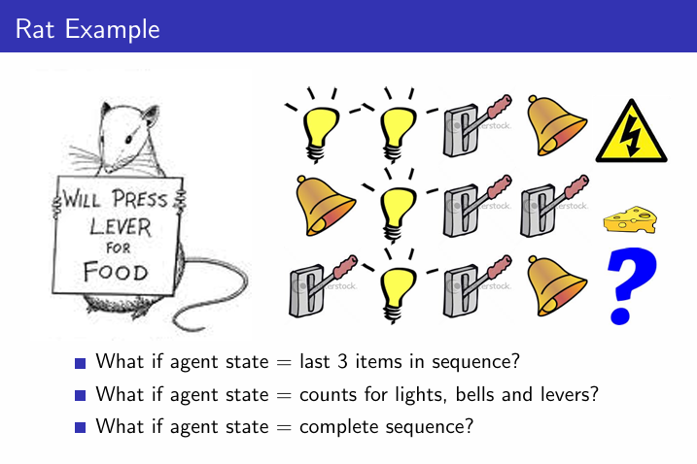

Throughout the course, you will learn about key concepts such as Markov Decision Processes, Dynamic Programming, Model-Free Prediction, Value Function Approximation, Policy Gradient Methods, Integrated Learning and Planning, and the balance between Exploration and Exploitation. By the end of the series, you will have the knowledge and skills to build an agent capable of performing in a classic game environment.

## 5. Reinforcement Learning Course - FreeCodeCamp

The [Reinforcement Learning Course](https://www.youtube.com/watch?v=ELE2_Mftqoc) by FreeCodeCamp is a YouTube course that is designed for beginners and covers the essentials of RL, including key algorithms and their implementation.

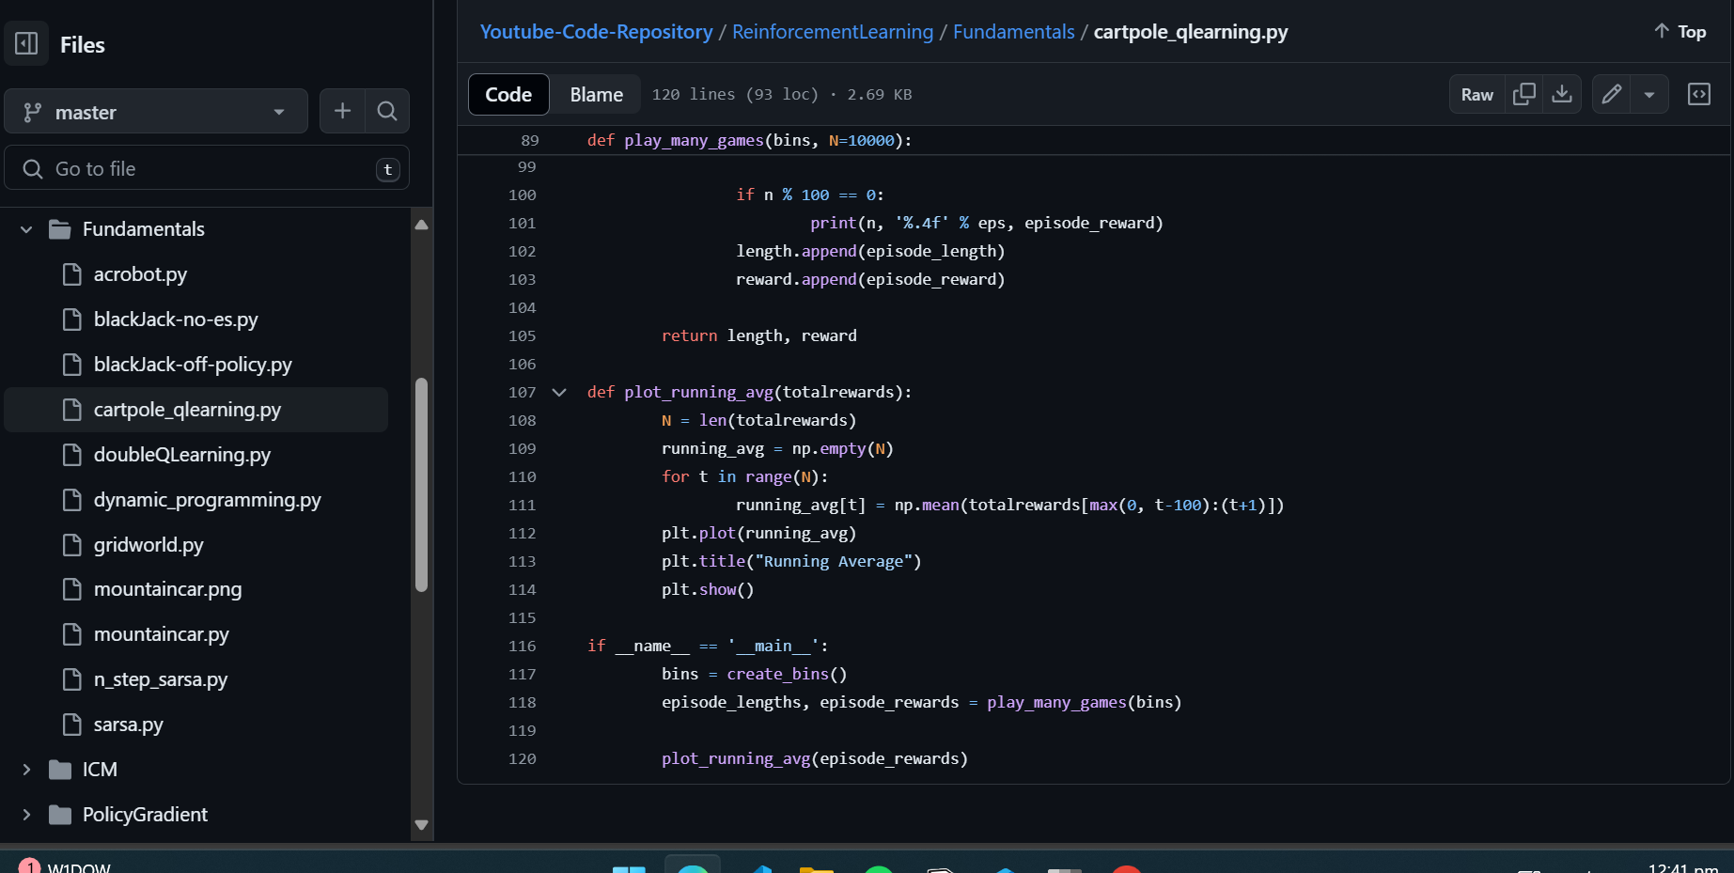

The course is project-oriented, allowing learners to apply what they've learned in practical scenarios. It's a great resource for those who prefer a more hands-on approach to learning.

## Conclusion

Reinforcement learning is a powerful AI technique that is driving advancements in various fields, including large language models like GPT-4 and LLaMA 3. Beyond language models, RL is also being used in robotics, self-driving cars, healthcare, trading, energy management, and more. If you are interested in working on Artificial General Intelligence (AGI) or simply want to enhance your AI skills, starting with reinforcement learning is essential. These free courses provide an excellent foundation to get you started on this exciting journey.